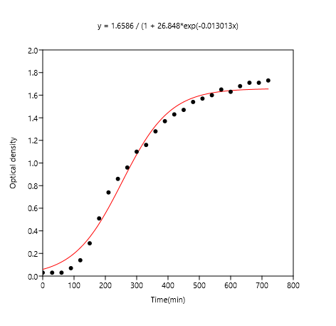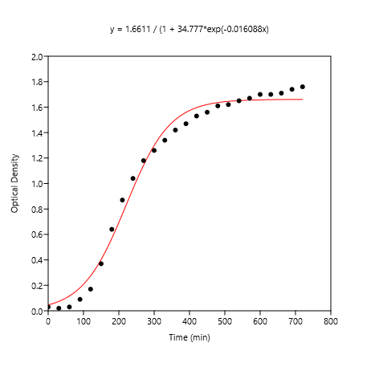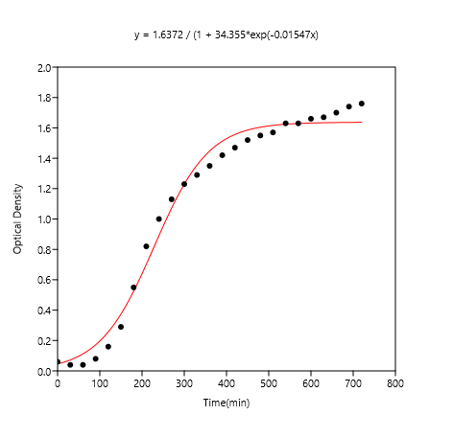

*pH 5.5, Ori pH 7, Ori pH 8.5, Ori*

-------------------------------------------------------------------------------------------------------------------------------------------------------------

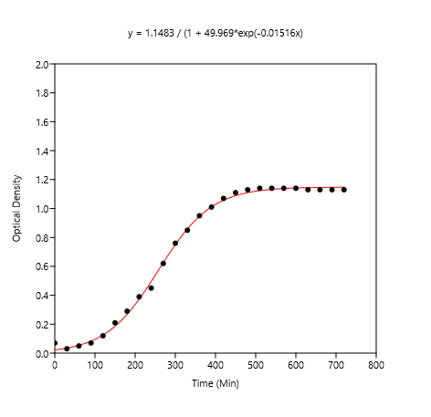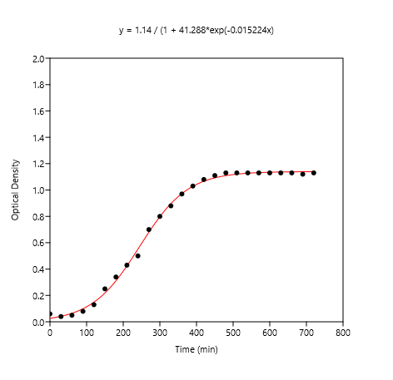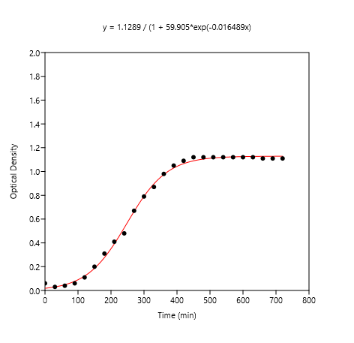

*pH 5.5, 1:5 dil pH 7, 1:5 dil pH 8.5, 1:5 dil*

-------------------------------------------------------------------------------------------------------------------------------------------------------------

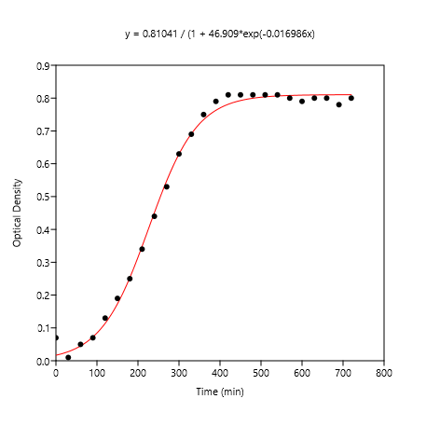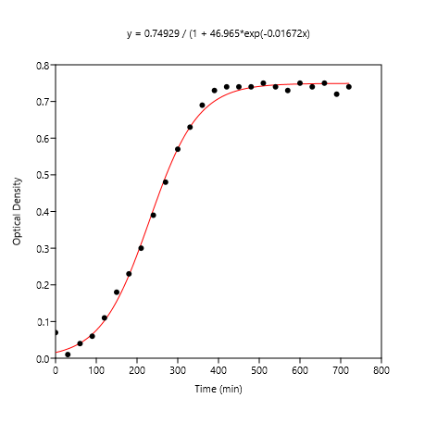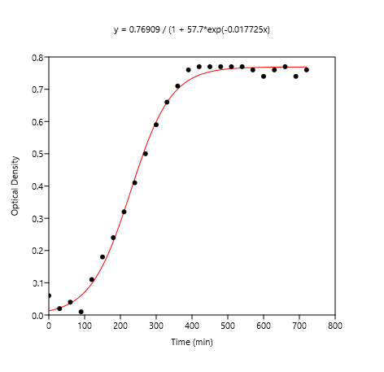

*pH 5.5, 1:10 dil pH 7, 1:10 dil pH 8.5, 1:10 dil*

